JA030R Series Cross Flow Fan

FEATURES

154mm (6.1in) to 366mm (14.4in) lengths. AC shaded type motor, temperature resistant aluminum alloy, ball or sleeve bearings. Maximum Pressure: 0.8mmAq (0.0315inH2O) to 1.7mmAq (0.067inH2O), Maximum Air Flow: 14CFM (0.4m³/min) to 60CFM (1.7m³/min). CE, UL, TUV listed.
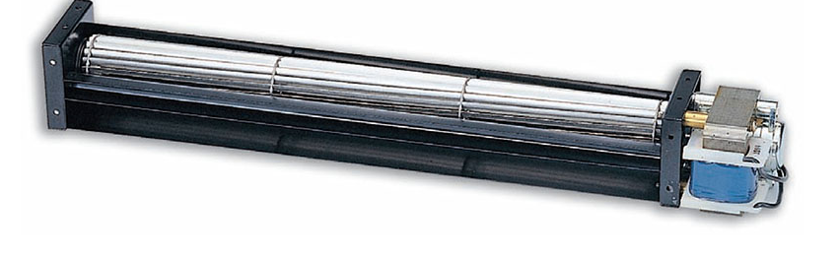

DIMINSIONS (size:mm)
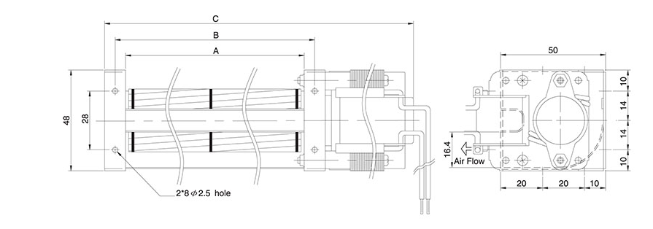
Dimensions and Specifications are subject to change without notice,
please refer to the actual product.

SPECIFICATIONS

Model \ Spec | Size(mm) |  |  | Rated  Voltage  V | Rated  Frequency  Hz | Rated  Current  A | Input  Power  W | Speed  r.p.m | Max  Pressure  mmAq | Maximun  Air Flow  m³/min | CFM | Noise  dBA | Safety Approval |  |  | Weight  g
Model \ Spec | A | B | C |  |  |  |  |  |  |  |  |  | UL | TUV | CE | Weight  g
JA03009R12 | 98 | 108 | 154 | 120 | 50/60 | 0.11/0.09 | 8/7 | 2500/2900 | 0.8/1.1 | 0.4/0.5 | 14/17 | 21/24 |  |  | O | 390g
JA03009R23 | 98 | 108 | 154 | 230 | 50/60 | 0.07/0.05 | 8/7 | 2500/2900 | 0.8/1.1 | 0.4/0.5 | 14/17 | 21/24 |  | O | O | 390g
JA03015R12 | 160 | 170 | 222 | 120 | 50/60 | 0.14/0.12 | 9/8 | 2700/3100 | 0.9/1.2 | 0.7/0.8 | 24/28 | 27/30 | O |  | O | 520g
JA03015R23 | 160 | 170 | 222 | 230 | 50/60 | 0.09/0.07 | 10/9 | 2700/3100 | 0.9/1.2 | 0.7/0.8 | 24/28 | 27/30 | O | O | O | 520g
JR03019R12 | 198 | 208 | 260 | 120 | 50/60 | 0.14/0.12 | 9/8 | 2700/3100 | 1.0/1.3 | 0.9/1.0 | 32/35 | 27/30 | O |  | O | 540g
JA03019R23 | 198 | 208 | 260 | 230 | 50/60 | 0.09/0.07 | 11/9 | 2700/3100 | 1.0/1.3 | 0.9/1.0 | 32/35 | 27/30 | O | O | O | 540g
JA03029R12 | 300 | 310 | 366 | 120 | 50/60 | 0.20/0.17 | 15/13 | 2700/3100 | 1.4/1.7 | 1.5/1.7 | 53/60 | 32/34 | O |  | O | 670g
JA03029R23 | 300 | 310 | 366 | 230 | 50/60 | 0.09/0.07 | 12/11 | 2700/3100 | 1.4/1.7 | 1.5/1.7 | 53/60 | 32/34 | O | O | O | 670g

P-Q CURVE

