JA040R Series Cross Flow Fan

FEATURES

160mm (6.3in) to 366mm (14.4in) lengths. AC shaded type motor, temperature resistant aluminum alloy, ball or sleeve bearings.Maximum Pressure: 1.7mmAq (0.066inH2O) to 2.6mmAq (0.10inH2O), Maximum Air Flow: 21CFM (0.6m³/min) to 70CFM (2.0m³/min) CE, UL, TUV listed.

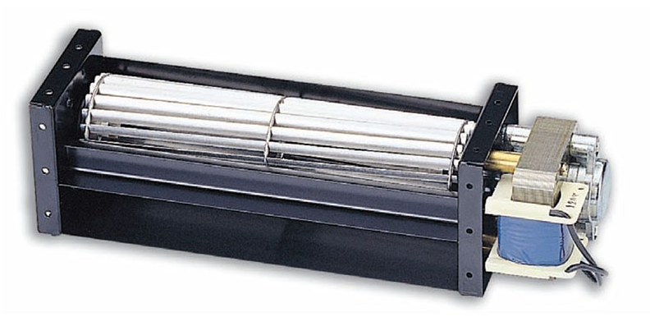

DIMINSIONS (size:mm)
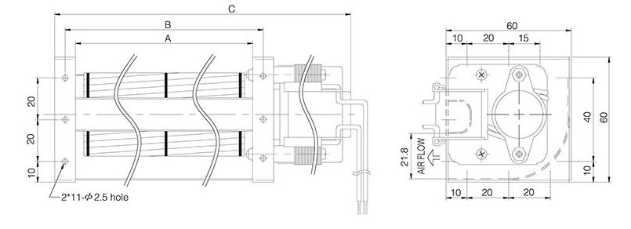
Dimensions and Specifications are subject to change without notice,
please refer to the actual product.
SPECIFICATIONS
Model \ Spec | Size(mm) |  |  | Rated  Voltage  V | Rated  Frequency  Hz | Rated  Current  A | Input  Power  W | Speed  r.p.m | Max  Pressure  mmAq | Maximun  Air Flow  m³/min | CFM | Noise  dBA | Safety Approval |  |  | Weight  g
Model \ Spec | A | B | C |  |  |  |  |  |  |  |  |  | UL | TUV | CE | Weight  g
JA04009R12 | 98 | 108 | 160 | 120 | 50/60 | 0.14/0.12 | 10/9 | 2700/3000 | 1.7/2.3 | 0.6/0.7 | 21/24 | 29/33 | O |  | O | 520g
JA04009R23 | 98 | 108 | 160 | 230 | 50/60 | 0.09/0.07 | 11/9 | 2700/3000 | 1.7/2.3 | 0.6/0.7 | 21/24 | 29/33 | O | O | O | 520g
JA04015R12 | 160 | 170 | 222 | 120 | 50/60 | 0.15/0.13 | 11/10 | 2600/2800 | 1.9/2.4 | 1.0/1.1 | 35/39 | 30/34 | O |  | O | 560g
JA04015R23 | 160 | 170 | 222 | 230 | 50/60 | 0.09/0.07 | 11/9 | 2600/2800 | 1.9/2.4 | 1.0/1.1 | 35/39 | 30/34 | O | O | O | 560g
JA04019R12 | 198 | 208 | 260 | 120 | 50/60 | 0.15/0.13 | 10/9 | 2500/2400 | 2.0/2.6 | 1.4/1.3 | 49/46 | 33/31 | O |  | O | 600g
JA04019R23 | 198 | 208 | 260 | 230 | 50/60 | 0.09/0.07 | 12/11 | 2500/2400 | 2.0/2.6 | 1.4/1.3 | 49/46 | 33/31 | O | O | O | 600g
JA04029R12 | 300 | 310 | 366 | 120 | 50/60 | 0.23/0.21 | 17/16 | 2400/2300 | 2.1/2.6 | 2.1/2.0 | 74/70 | 37/35 | O |  | O | 730g
JA04029R23 | 300 | 310 | 366 | 230 | 50/60 | 0.10/0.09 | 13/13 | 2400/2300 | 2.1/2.6 | 2.1/2.0 | 74/70 | 37/35 | O | O | O | 730g

